Trinity Evangelical Lutheran Church of Pleasant Valley
2170 PA-212 • Coopersburg, PA 18036-9770 • An ELCA Congregation
Telephone 610.346.7282 • Email office@trinitypv.org • trinitypv.org
Rev. Tyler Rasmussen, Pastor
Mobile 610.635.9964 • Email pastor@trinitypv.org
Parents and Bear Creek Day Camper(s):

Thank you for your interest Bear Creek Day Camp. This year we’ll be hosting camp from Tuesday, June 27 through Thursday, June 29 from 8:00 a.m. to 5:00 p.m. The camp is open to children, grades K-5.

In this packet you’ll find 3 documents:
- A letter explaining in more detail everything you need to know about Bear Creek Day Camp.
- A registration form. Please fill out this form in its entirety and either submit via mail or email (address can be found in the header of this letter). Advance registration is greatly appreciated (we do accept registration at the door if you found out about camp last minute).
- A media release and holds harmless form. This form repeats the exact language you already found on the registration form for Bear Creek, but this one applies to Trinity Lutheran. Our congregation is glad to host Bear Creek Day Camp and will have a staff member or trusted volunteer around at all times, but the camp is the product of and being run by Bear Creek.
  - If you cannot sign either form for media reasons, please contact us and we’ll provide you an alternate form without the media release. We post photos (without names or other identifying information) on our Facebook page during camp so that you can see how things are going with your children. In addition, we use these photos in our annual internal records, but we understand that some children are in situations where photos are not possible.
The cost for this 3-day camp will be $75 (roughly $2.50 an hour) per participant. If cost is an issue, please contact us for alternate arrangements. We’ll work hard to meet your financial ability!
Please submit the registration form and media release / holds harmless form to the above postal address or email, along with a check for $75 per participant made out to “Palisades Lutheran Cluster”. You can find additional copies of the forms online at trinitypv.org/day-camp
In Christ’s love,
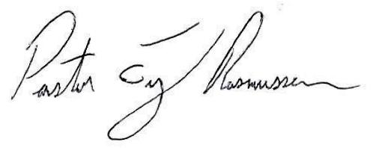
Rev. Tyler Rasmussen, Pastor

